Getting Started with ODM

Instructions for Attaching the ODM Blank Schema Database
to an Instance of Microsoft SQL Server 2005

Jeffery S. Horsburgh

5-3-2008

Introduction

This document describes how to attach the ODM blank SQL Server schema database to your instance of SQL Server so that you can get started with using ODM. In order to do so, you must be running a version of Microsoft SQL Server 2005 (i.e., Express, Standard, or Enterprise). If you do not already have an instance of Microsoft SQL Server running, you can download and install Microsoft SQL Server 2005 Express from Microsoft for free. It is recommended that you download and install both SQL Server 2005 Express and SQL Server Management Studio Express. You can get both of these products in a single installation (download and install the SQL Server 2005 Express Edition with Advanced Services SP2) as well as installation instructions at the following Microsoft URL:

http://www.microsoft.com/sql/editions/express/default.mspx

When you install SQL Server 2005 Express, it is recommended that you enable mixed mode authentication (both SQL Server authentication and Windows authentication). This will allow you to work with the ODM Tools OMD Data Loader, and ODM Streaming Data Loader applications that have been developed for ODM. These applications rely on SQL Server authentication to connect to ODM databases, and SQL Server authentication is only enabled when you choose the mixed mode authentication during installation. When you enable mixed mode authentication during installation, you will be prompted to create a password for the “sa” logon. The “sa” login is the administrative account and allows you to manage all other logins. Choose a password that you will remember as you will use this account frequently.

Attaching the Blank ODM Schema Databases to SQL Server

The following are the steps required to attach the blank ODM schema database to an instance of Microsoft SQL Server. These steps were written using SQL Server Management Studio Express; however, the steps are similar regardless of which version of the Microsoft SQL Server Management Studio you are using.

- Extract the blank schema database and its log file from the zip file to a location on your hard drive using WinZip or some other equivalent software. It is suggested that you extract your database to the default SQL Server data folder, which is located at the following location on disk: C:\Program Files\Microsoft SQL Server\MSSQL.1\MSSQL\Data\

NOTE: You can extract your blank schema databases to any location on disk. However, if you do so and you have connected to SQL Server using SQL Server authentication and not Windows Authentication, you will have to give SQL Server access to read and write to the folder where you extracted your database prior to attaching it. SQL Server already has access to its default data folder using either SQL Server or Windows authentication and so this is the easiest location in which to work.

- Open the Microsoft SQL Server Management Studio Express from the Start Menu by clicking on Start --- All Programs --- Microsoft SQL Server 2005 --- SQL Server Management Studio Express. The following window will appear.

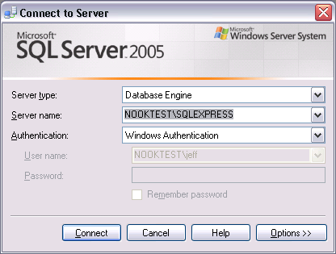

NOTE: The path to your SQL Server Management Studio shortcut in the Start menu may be different depending on which version of SQL Server you have installed and where you chose to put the shortcut in the Start Menu.

- It is assumed that you are connecting to your local instance of SQL Server. You should see your computer’s name followed by “\SQLEXPRESS” in the “Server Name” drop down. In the following figure, the computer’s name is “NOOKTEST.” Change the Authentication dropdown to “SQL Server Authentication,” enter “sa” for your login, and then enter your administrative password in the “Password” text box. Your login screen should look similar to the following.

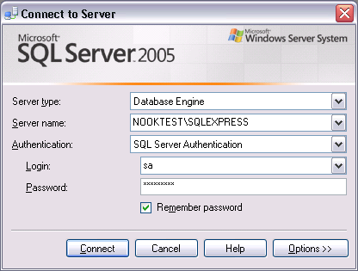

NOTE: You can complete these steps using Windows authentication rather than SQL Server authentication. However, if you wish to use the ODM Tools application with this database you will be required to have a SQL Server authentication login for the database that you are attaching.

- Click on the “Connect” button. This will connect the Management Studio to your local SQL Server instance. Your Management Studio window should look similar to the following.

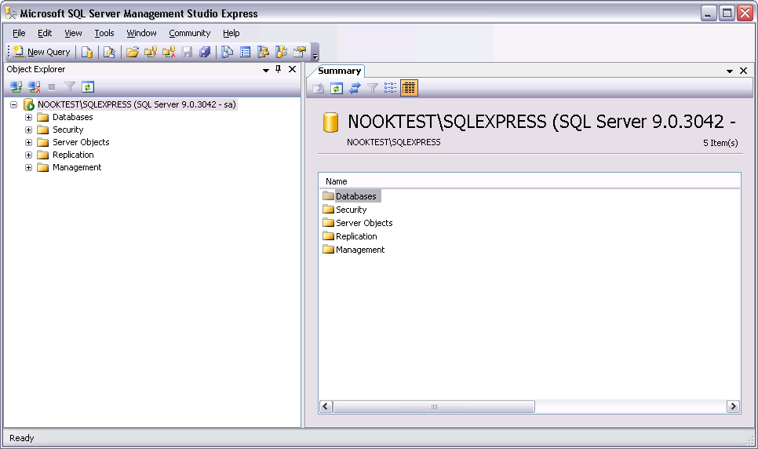

- Right click on the “Databases” item under your server in the Object Explorer at the left of the window and choose “Attach” from the context menu. The following window will appear.

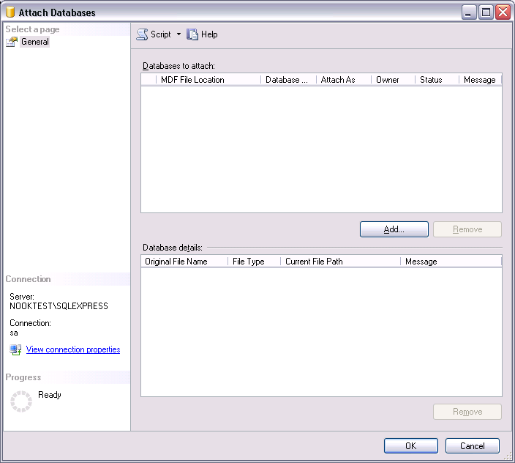

- Click on the “Add” button near the center of the form. In the window that opens, navigate to the location on your hard drive where you extracted the ODM test database. Select the .mdf file associated with the database that you want to attach (OD.mdf). See the following figure for an example.

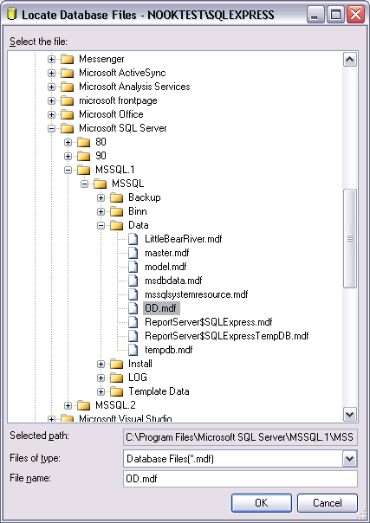

- Click the “OK” button. This will return you to the “Attach Databases” form and will populate that form with the information needed to attach the database that you have selected. You will notice that your selected database is listed in the “Databases to attach” section and that the details of your database files are shown at the bottom of the form. See the following figure.

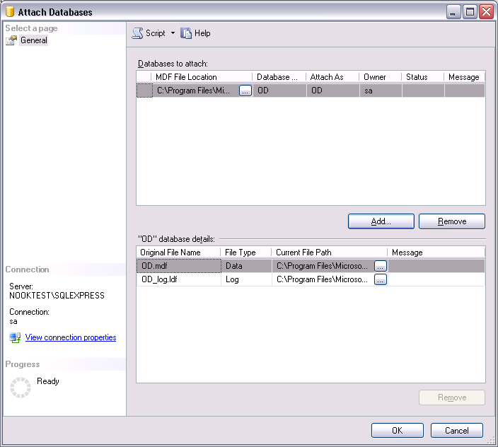

- Click the “OK” button and then wait for a moment while the blank schema database is being attached.

- Once the database has been attached, expand the “Databases” item under your server in the Object Explorer by clicking on the plus sign next to “Databases.” You should now see an item under “Databases” for the database that you just attached. If you do not see an item for the OD database, right click on the “Databases” item and choose “Refresh” from the context menu. You can further expand the OD database by clicking on the plus sign next to its name and then clicking on the plus sign next to “Tables” (see the following figure).

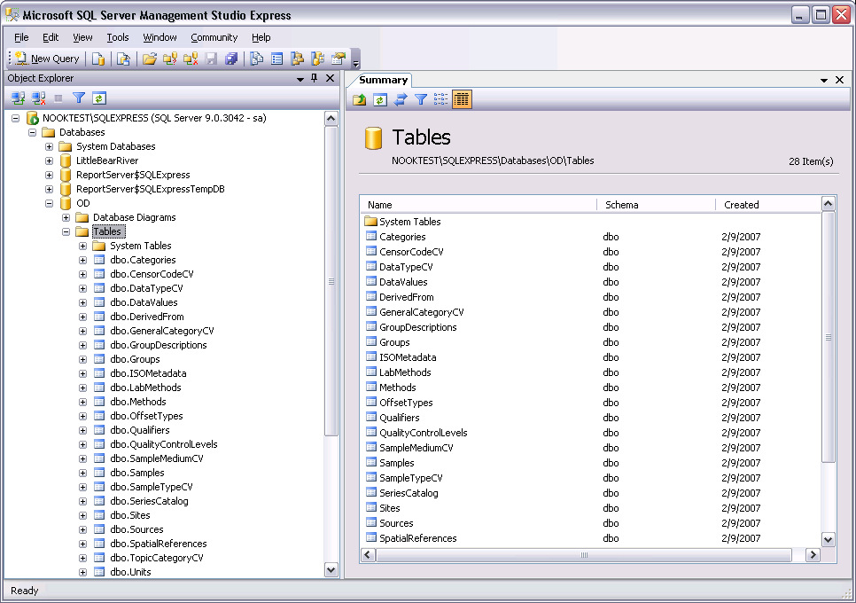

- Although there is no data in the blank schema database, you can view the contents of the controlled vocabulary tables in the OD database by right clicking on them in the Object Explorer and choosing “Open Table” from the context menu (see the following for the Units table).

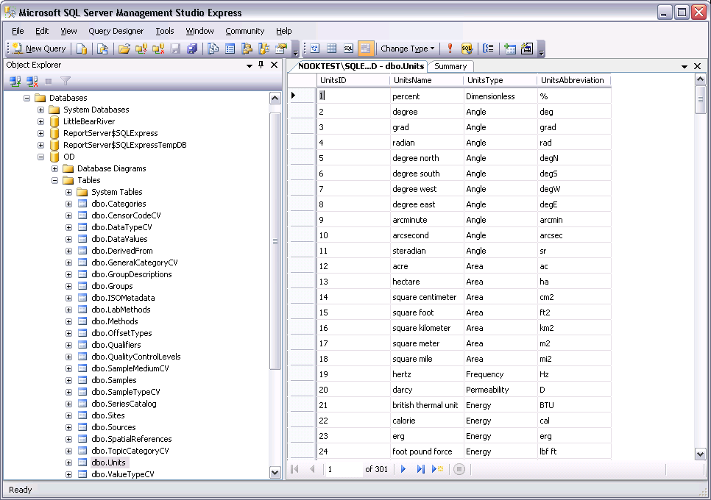

- You are now ready to begin adding data to your ODM SQL Server database.

Acknowledgements

This material is based upon work supported by the National Science Foundation under Grant Nos. EAR 0412975 and 0413265.

Any opinions, findings and conclusions or recommendations expressed in this material are those of the authors and do not necessarily reflect the views of the National Science Foundation (NSF).

Utah Water Research Laboratory, Utah State University, Logan, UT 84322-8200, jeff.horsburgh@usu.edu

